CAB420 Problem Solving Task ASSIGNMENT 1 (N11968991)

Problem 1

1.0 Overview
The dataset contains community-level socio-economic, demographic, and law enforcement variables used to predict the proportion of violent crimes per population (ViolentCrimesPerPop). It includes over 100 numerical features describing factors such as income, employment, housing, and population characteristics.
The data is provided in predefined training, validation, and test splits, which are used without modification. Due to the high number of features and potential correlations between variables, the dataset is well-suited for comparing linear and regularised regression models.

1.1 Pre-processing
No pre-processing was done on the data, as there were no missing values in the datasets provided.

1.2 Linear Regression
The linear regression model was fitted directly to the training data and was used as a baseline. The linear regression model achieved a training RMSE of 0.1042, a validation RMSE of 0.1549, and a test RMSE of 0.1533, with corresponding $R^{2}$values of 0.7591, 0.6209, and 0.5531 respectively.
The model performs substantially better on the training data than on the validation and test sets, indicating a degree of overfitting. While the model captures a large proportion of variance in the training data, its predictive performance decreases on unseen data, suggesting limited generalisation.
The model uses all 100 predictors. However, the OLS summary shows that many predictors have high p-values, indicating that they are not statistically significant contributors to the model.
This suggests the presence of multicollinearity between socio-economic variables and that many variables contribute less when others are implemented.
Residual analysis shows that the model assumptions are not fully satisfied. The Q-Q plot (Figure 1.1) indicates deviations from normality, particularly in the tails, suggesting skewness and the presence of outliers. The residuals vs predicted plot (Figure 1.2) shows visible structure rather than random scatter, indicating that the model does not fully capture the underlying relationships and suggesting heteroscedasticity. This is further supported by the actual vs predicted plot (Figure 1.3), which shows noticeable spread around the ideal diagonal line, indicating prediction error, particularly for higher values.
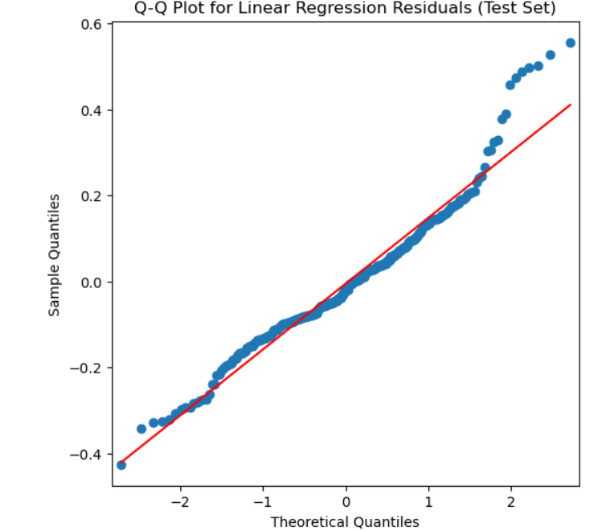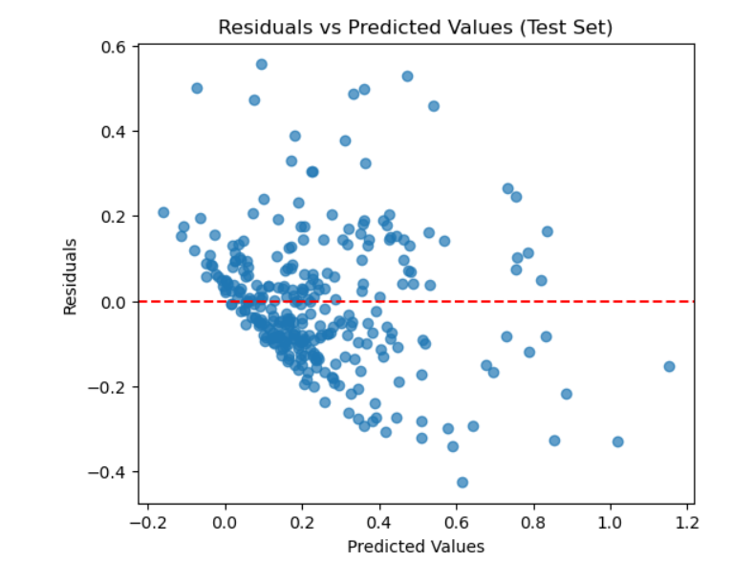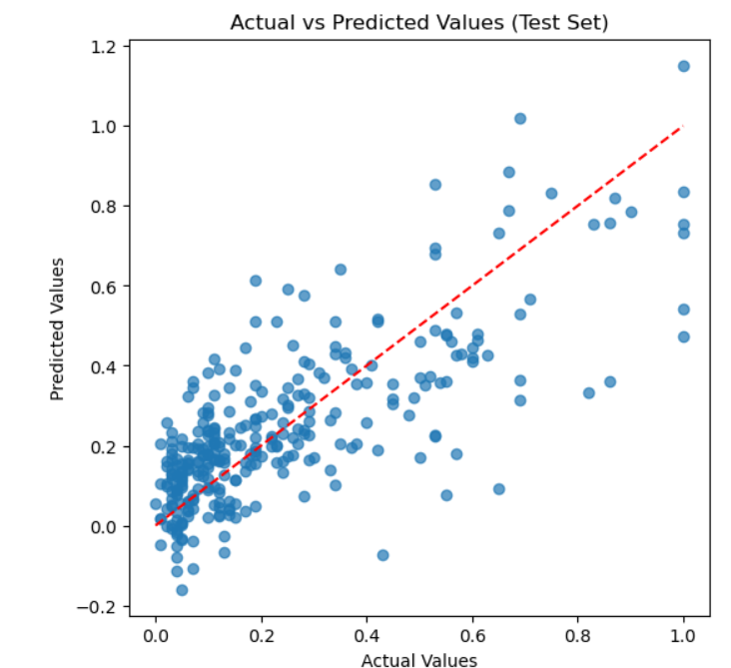
Figure 1.2: Residuals vs fitted values for linear regression. Some structure is visible, suggesting non-ideal residual behaviour.
Figure 1.3: Actual vs predicted values for linear regression. A positive relationship is observed, with some spread indicating prediction error.
Figure 1.1: Q-Q plot of linear regression residuals. Points mostly follow the line, with slight deviations at the tails.

1.3 Ridge and Lasso Regression
For Ridge regression, the optimal value was approximately 1.0, and produced a improvement over the linear regression with the testing and validation data yielding better results compared to the linear model, with validation data having a 0.1427 RMSE and a higher R^2 of 0.6786 and testing data yielding a 0.1333 lower RMSE and a higher R^2 of 0.6619.
As seen in Figure 1.4, the RMSE is the lowest when the Alpha reaches closer to 1, therefore, making the optimal value approximately 1.
For Lasso regression, the optimal value is 0.001 and yielded the best testing results with the lowest test RMSE of 0.1308 and the highest test R^2 of 0.6745. As seen in Figure 1.6, 41 of the coefficients were removed by the model to make it more basic and generalised.
As seen in the Figure 1.5, the RMSE sees a significant dip when the alpha value reaches approximately 0.001, therefore it was used as the alpha value for this model.
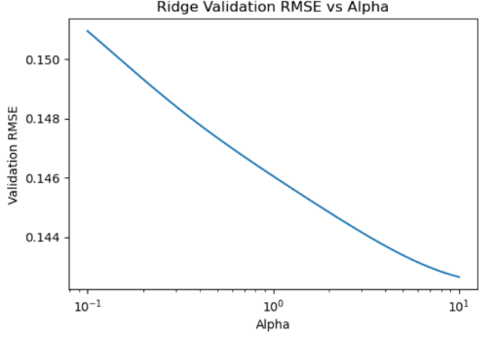
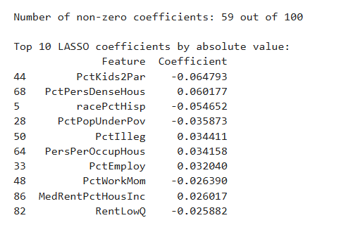
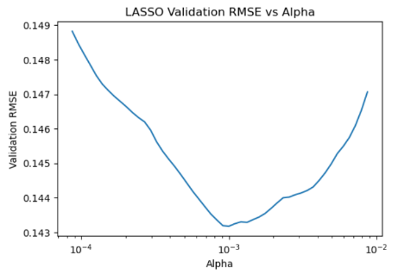

Figure 1.6: Top 10 LASSO coefficients by absolute value. Only a subset of features remain non-zero, indicating effective feature selection.
Figure 1.5: LASSO validation RMSE vs alpha. Error decreases to a minimum and then increases, showing the trade-off between underfitting and over-regularisation.
Figure 1.4: Ridge regression validation RMSE vs alpha. Error decreases as alpha increases, indicating improved generalisation with stronger regularisation.

1.4 Comparison and Model Validity
The three models were compared based on predictive accuracy, model complexity, and validity, with results summarised in Figure X. Linear regression achieved the lowest training error but performed worse on the validation and test sets, indicating overfitting and limited generalisation. Ridge regression improved performance by reducing RMSE and increasing R^2 on unseen data, demonstrating that regularisation helped mitigate multicollinearity and stabilise the model. As seen in Table 1.1, LASSO regression produced the best overall results, achieving the lowest test RMSE (0.1308) and highest test R^2(0.6745), indicating superior predictive performance. In addition, LASSO reduced model complexity by eliminating 41 predictors, retaining only 59 out of 100 variables, which improves interpretability and suggests that many socio-economic features contribute minimally once redundancy is addressed.
LASSO regression performed the best on unseen data followed by Ridge, with linear regression performing the worst. LASSO demonstrates the best generalisation performance out of all three models.
In terms of model validity, linear regression violated several key assumptions, including non-normal residuals and heteroscedasticity, as observed in the residual analysis. While Ridge and LASSO improved generalisation and reduced the impact of multicollinearity, some deviations from ideal assumptions remained, reflecting the inherent complexity and variability of socio-economic data. Given that violent crime is influenced by numerous interacting and unobserved factors, perfect model validity is not expected. Therefore, while regularised models provide more reliable and generalisable predictions, all models should be interpreted as approximations rather than exact representations of real-world relationships.
Table 1.1: Comparison of regression models. LASSO achieves the lowest RMSE and highest $R^{2}$, indicating the best overall performance.
Model | Test RMSE | Test R²
Linear Regression | 0.1533 | 0.5531
Ridge Regression | 0.1427 | 0.6127
LASSO Regression | 0.1308 | 0.6745

1.5 Ethical Considerations
The use of socio-economic data to model violent crime raises several important ethical concerns. The dataset includes sensitive demographic and economic variables, which may reflect historical and systemic biases. As a result, the model may unintentionally reinforce existing inequalities or be misinterpreted in ways that unfairly stigmatise certain communities. Additionally, the relationships identified by the model are correlational rather than causal, meaning that variables associated with crime should not be interpreted as direct causes. There are also likely confounding factors, such as policing practices, reporting rates, and historical inequalities, that are not fully captured in the data. If used in decision-making, such models could lead to biased or disproportionate allocation of resources, potentially creating feedback loops that reinforce disadvantage. Therefore, while the models are useful for identifying patterns, their limitations must be clearly acknowledged, and they should be applied cautiously to avoid misinterpretation or harmful outcomes.

Problem 2

2.0 Overview
This section investigates the classification of land use types based on 27 spectral features. Three multi-class classification models, K-Nearest Neighbours, Random Forest, and Support Vector Machine, were trained using the provided training and validation datasets, with hyperparameters optimised through grid search. The final models were then evaluated on the test set to compare their generalisation performance and analyse differences in model behaviour.

2.1 Pre-processing
Feature standardisation was applied using a StandardScaler to ensure all spectral features were on a comparable scale. This is particularly important for KNN and SVM, as both rely on distance calculations and can be biased by features with larger magnitudes. The scaler was fitted on the training set and then applied to the validation and test sets to avoid data leakage. Standardisation was not applied to Random Forest, as tree-based models are not affected by feature scaling.

2.2 Hyperparameter Selection and Analysis
Hyperparameters for each model were selected using a grid search approach implemented via nested loops on the validation set. A predefined set of candidate values was evaluated for each hyperparameter, and the configuration that achieved the highest macro F1-score on the validation set was selected. Macro F1 was used as the selection metric as it provides a balanced evaluation across all classes, which is important in multi-class classification tasks.
The search grids were intentionally kept coarse to ensure reasonable computational cost while still capturing meaningful variations in model behaviour.

2.3 K-Nearest Neighbours (KNN)
The grid explored values of k ∈ {1, 3, 5, 7, 9, 11, 15, 21}, distance metrics {Euclidean, Manhattan}, and weighting schemes {uniform, distance}. Odd values of k were chosen to avoid ties in voting, while the range allows exploration from highly local models (small k) to smoother, more generalised models (large k).
The optimal configuration was k = 1, Manhattan distance, and uniform weighting. A small value of k means the model relies heavily on the nearest neighbour, resulting in highly flexible decision boundaries. This allows the model to capture fine-grained local structure in the data, but also increases sensitivity to noise and outliers. The selection of Manhattan distance suggests that absolute differences between spectral features may better capture similarity than Euclidean distance for this dataset.

2.4 Support Vector Machine (SVM)
The grid explored values of C ∈ {0.1, 1, 10}, kernel ∈ {linear, RBF}, gamma ∈ {scale, auto}, and multi-class scheme ∈ {one-vs-one, one-vs-rest}. The parameter C controls the trade-off between model complexity and generalisation, where smaller values encourage smoother decision boundaries and larger values allow tighter fitting to the training data.
The optimal configuration was C = 0.1 with a linear kernel and gamma = scale, using the default one-vs-one scheme. The low value of C indicates that the model benefits from a simpler decision boundary that generalises well rather than attempting to fit every training point. The selection of a linear kernel suggests that the classes are approximately linearly separable in the transformed feature space, and that more complex non-linear kernels are unnecessary.

2.5 Random Forest (RF)
The grid explored n_estimators ∈ {50, 100, 200} and max_depth ∈ {5, 10, None}. Increasing the number of trees improves stability and reduces variance, while maximum depth controls model complexity.
The optimal configuration was n_estimators = 50 and max_depth = 5. A shallow tree depth limits overfitting and produces a more generalised model, but may restrict the model’s ability to capture complex relationships between features. The relatively small number of trees suggests that additional trees did not significantly improve performance, indicating diminishing returns.
Overall, the selected hyperparameters reflect a preference for simpler, more generalisable models. This suggests that the dataset does not require highly complex decision boundaries to achieve good performance.

2.6 Model Evaluation and Comparison
The final models were evaluated on the test set using accuracy and macro F1-score, as shown in Table 2.1.
Table 2.1: Comparison of classification models. SVM achieves the highest accuracy and macro F1 score, indicating the best overall performance among the models.
Model | Accuracy | Macro F1
SVM | 0.8385 | 0.8194
KNN | 0.8199 | 0.7927
Random Forest | 0.7950 | 0.7880

SVM achieved the best overall performance, with the highest accuracy and macro F1-score, indicating strong and balanced classification across all classes. KNN performed slightly worse, while Random Forest achieved the lowest performance.
Analysis of the confusion matrices (Figures 2.1–2.3) reveals consistent patterns of misclassification across all models. A common source of error is the confusion between soil (s) and healthy vegetation (h). In the KNN model (Figure 2.1), 8 instances of soil were misclassified as healthy vegetation, while 3 instances of healthy vegetation were misclassified as soil. This pattern persists in the SVM model (Figure 2.2), where 10 soil instances were incorrectly classified as healthy vegetation, although SVM improved overall performance for class h, correctly identifying 14 out of 15 instances.
Another notable pattern is confusion between dry vegetation (d) and other classes (o). In KNN (Figure 2.1), 9 instances of class o were misclassified as d, and in Random Forest (Figure 2.3), 7 instances of class o were similarly misclassified. Random Forest also showed additional confusion between dry vegetation and soil, with 10 instances of class d incorrectly classified as s.
KNN achieved strong performance on class d but showed weaker performance on class h, indicating less reliable predictions for that class. In contrast, SVM (Figure 2.2) demonstrated more balanced performance across all classes, with clearer diagonal dominance in the confusion matrix. Random Forest (Figure 2.3) performed moderately but showed less consistency, particularly in distinguishing between visually similar classes such as soil and dry vegetation.
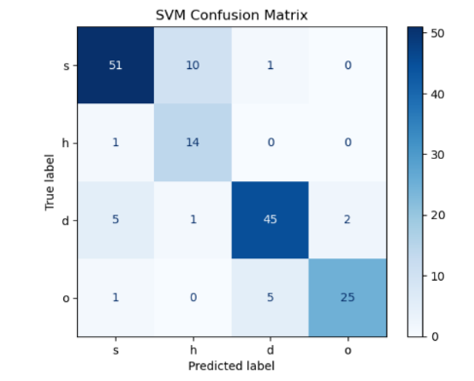
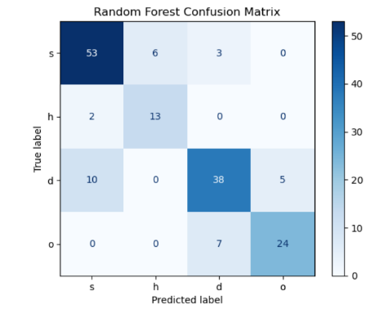
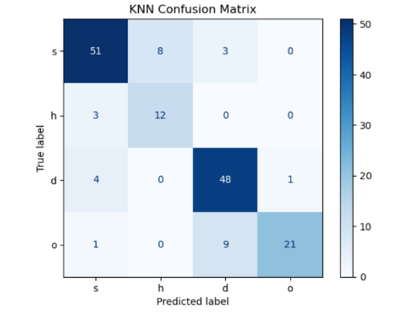
Overall, the results indicate that SVM is the most effective model for this task. Its ability to form clearer decision boundaries allows it to better separate overlapping classes, whereas KNN is more sensitive to local noise and Random Forest struggles to consistently distinguish between similar classes.
Figure 2.3: Random Forest confusion matrix. Good overall performance, though more misclassification is observed compared to SVM.

Figure 2.2: SVM confusion matrix. Strong diagonal pattern indicates accurate classification, with fewer misclassifications than KNN.

Figure 2.1: KNN confusion matrix. Most predictions lie along the diagonal, with some confusion between similar classes.

Problem 3

3.0 Overview
The aim of this part is to train two CNN models that predict the true digit from images. The first CNN model is un-augmented while the other CNN model is augmented, meaning that the image can be cropped, rotated or translated to help the model better predict the digit. The data being provided is in a .mat format where the X data is the image and the Y data is the truth label. The truth label is a label that identifies the true value of the digit being shown in the image. Each image is showing one main digit that is centred. While there may be other digits in the image, they are to be treated as noise and the model must predict correctly the main digit.

3.0 OVERVIEW
This task investigates the use of deep convolutional neural networks (DCNNs) for image classification on the Street View House Numbers (SVHN) dataset, which consists of real-world 32×32 colour images of digits. The dataset contains significant variability, including noise, lighting differences, and partial overlapping digits, making it more challenging than standard digit datasets.
Two identical DCNN models were trained using the provided limited training dataset: one using the original data and one using data augmentation to increase variability. These models were compared against a baseline Support Vector Machine (SVM) in terms of classification accuracy, training time, and inference time. The objective was to evaluate how model architecture and training strategy influence performance, particularly when training data is limited.

3.1 NEURAL NETWORK DESIGN AND TRAINING APPROACH
A deep convolutional neural network (DCNN) was selected due to its effectiveness in image classification tasks, particularly for learning spatial features such as edges, strokes, and shapes present in digit images. The architecture used was based on standard CNN designs introduced in lectures and practicals, rather than being developed from scratch, as these architectures are widely used and proven effective across many image classification problems.
The network consisted of three convolutional layers with filter sizes of 32, 64, and 128, each followed by max pooling layers to progressively extract higher-level features while reducing spatial dimensions. These were followed by a fully connected dense layer with 128 units and a dropout layer (rate = 0.5) to reduce overfitting. The final layer used a softmax activation function to classify the input into one of the 10 digit classes.
No additional preprocessing such as resizing or grayscale conversion was applied. The images were retained in their original 32×32 RGB format, and pixel values were normalised to the range [0,1]. For the SVM model, the images were vectorised into one-dimensional feature vectors, as required by traditional machine learning methods.
The model was trained using the Adam optimiser with a learning rate of 0.0001 and sparse categorical cross-entropy loss. A batch size of 32 was used to ensure sufficient gradient updates per epoch.
The models were trained for up to 50 epochs (non-augmented) and 60 epochs (augmented), with early stopping applied based on validation loss. Early stopping ensures that training continues only while the model is improving, and automatically terminates training once performance stabilises, restoring the best weights. This approach effectively allows the model to train to convergence without requiring a fixed number of epochs.
A higher epoch limit was used for the augmented model as the additional variability introduced by data augmentation increases the difficulty of the learning process and slows convergence. As a result, the augmented model required more training iterations to reach stable performance compared to the non-augmented model.
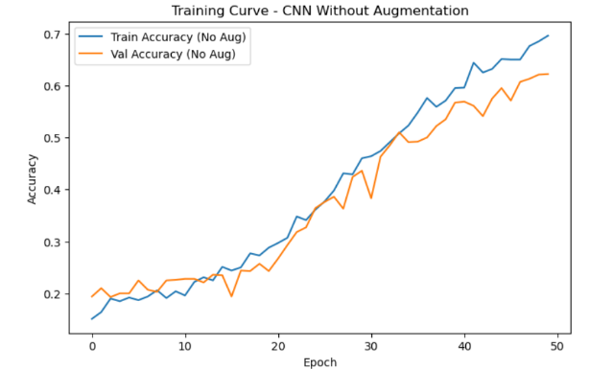
The DCNN without augmentation demonstrated clear convergence, as shown by increasing and stabilising validation accuracy and decreasing loss (Figure 3.1). The model achieved a test accuracy of 64.83%, indicating strong learning despite the limited dataset.
Figure 3.1: Training accuracy curves for CNN without augmentation. Training accuracy exceeds validation accuracy, indicating mild overfitting.

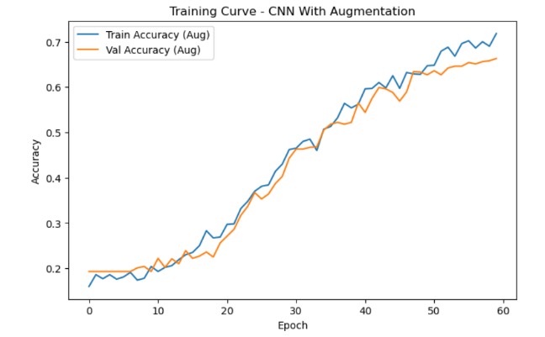
The DCNN with augmentation also converged successfully, although it required longer training time due to the increased complexity of augmented data. Training and validation curves remained closely aligned (Figure 3.2), indicating improved generalisation and reduced overfitting compared to the non-augmented model. The final test accuracy achieved was 70.45%, demonstrating improved performance.

Figure 3.2: Training accuracy curves for CNN with augmentation. Training and validation accuracy remain closely aligned, indicating improved generalisation.

3.2 DATA AUGMENTATION
Data augmentation was applied using small random transformations, including rotations (±3%), width and height shifts (±3%), and zoom (±2%), as shown in Figure 3.4. These transformations were selected to simulate realistic variations in digit positioning, alignment, and scale within the SVHN dataset.
Initially, stronger augmentation parameters were used (rotation ±8%, translation ±8%, and zoom ±8%). However as seen in Figure 3.3, this caused the model to collapse during training, where it predicted almost all samples as a single class (class 2). This resulted in extremely poor performance and indicated that the transformations were too aggressive for small 32×32 digit images.
Excessive augmentation distorted the structure of the digits, making them difficult for the model to recognise. As a result, the augmentation parameters were reduced to smaller values (rotation 0.03, translation 0.03, zoom 0.02), allowing the model to learn effectively while still benefiting from increased data variability.
Transformations such as flipping were not used, as they would alter the semantic meaning of digits (e.g., converting a “6” into a “9”). The final augmentation strategy preserves digit identity while introducing realistic variation, improving generalisation performance.
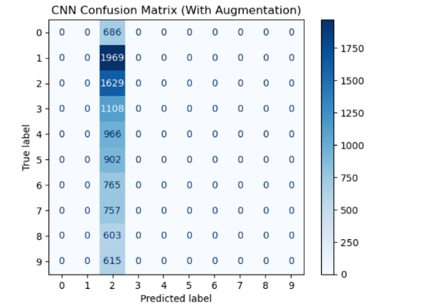
Figure 3.3: Confusion matrix for CNN with initial augmentation. Model collapses to predicting a single class, indicating overly aggressive augmentation.

3.3 COMPARISON OF MODELS
The models were compared using a baseline SVM and two DCNN configurations (with and without augmentation), evaluated using test accuracy, macro F1 score, training time, and inference time.
Model | Test Accuracy | Test F1 Score | Training Time (s) | Inference Time (s)
SVM | 0.1861 | 0.1409 | 1.6826 | 5.4856
CNN (No Augmentation) | 0.6483 | 0.5775 | 74.1903 | 3.3149
CNN (With Augmentation) | 0.7045 | 0.6550 | 99.3179 | 3.1547
Table 3.1: Comparison of model performance. CNN with augmentation achieves the highest accuracy and macro F1 score, indicating the best overall performance.

The SVM model achieved a test accuracy of 18.61% and a macro F1 score of 0.1409, indicating very poor performance. While accuracy alone suggests weak predictive capability, the extremely low macro F1 score further highlights that the model performs poorly across all classes, particularly failing to correctly classify less frequent or more complex digits. As shown in Table 3.1, the SVM records the lowest performance across all metrics. The confusion matrix (Figure 3.6) shows widespread misclassification with no clear diagonal pattern, demonstrating that the SVM is unable to capture spatial relationships after vectorisation.
The DCNN without augmentation significantly outperformed the SVM, achieving a test accuracy of 64.83% and a macro F1 score of 0.5775 (Table 3.1). The improvement in macro F1 score indicates that the model is not only more accurate overall, but also performs more consistently across different digit classes. The confusion matrix (Figure 3.4) shows a clear diagonal pattern, indicating correct classification for many samples. However, some imbalance remains, particularly for more visually complex digits such as 8 and 9, which contributes to the gap between accuracy and macro F1 score.
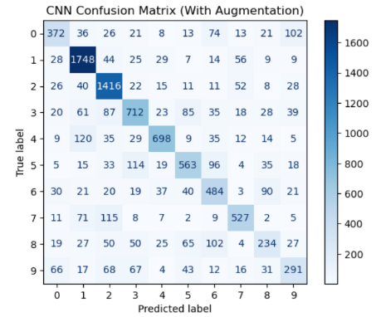
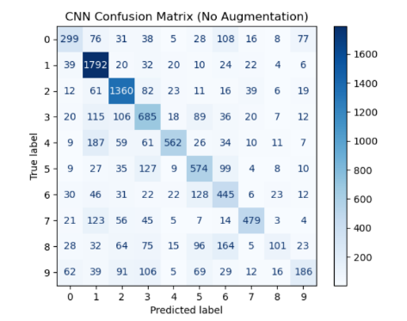
The DCNN with augmentation achieved the best performance, with a test accuracy of 70.45% and a macro F1 score of 0.6550 (Table 3.1). The increase in macro F1 score compared to the non-augmented model indicates improved performance across all classes, not just the most frequent or easier ones. The confusion matrix (Figure 3.5) shows stronger diagonal dominance and more evenly distributed predictions, suggesting that the model generalises better and handles class variability more effectively.
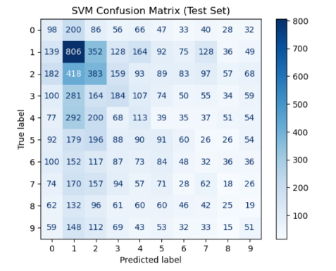

Figure 3.6: Confusion matrix for SVM. Weak diagonal pattern shows poor classification performance across most classes.
Figure 3.5: Confusion matrix for CNN with augmentation. Improved diagonal dominance indicates better generalisation and more balanced predictions.
Figure 3.4: Confusion matrix for CNN without augmentation. Strong diagonal pattern with some misclassification between similar digits.

3.4 TRAINING AND INFERENCE TIME
As shown in Table 3.1, the SVM model trained the fastest (1.68 seconds) but required the longest inference time (5.49 seconds), due to the need to evaluate support vectors during prediction.
The DCNN without augmentation required 74.19 seconds to train, while the augmented DCNN required 99.32 seconds, reflecting the additional computational cost of applying transformations during training. However, both CNN models achieved faster inference times (approximately 3.2 seconds) compared to the SVM.
These results demonstrate that while CNNs are more computationally expensive to train, they provide significantly better predictive performance and more efficient inference once trained.

3.5 INTERPRETATION
The results demonstrate that deep convolutional neural networks are significantly more effective than traditional machine learning approaches for image classification tasks. The SVM performed poorly due to its inability to capture spatial information, while the CNN successfully learned meaningful visual features.
Data augmentation further improved performance by increasing the diversity of the training data and reducing overfitting. The augmented model achieved higher accuracy and more balanced predictions across all classes.
However, the experiment also highlights that augmentation must be carefully configured. Excessive augmentation can distort input data and negatively impact learning, as observed when the model collapsed to predicting a single class. Properly tuned augmentation provides a strong improvement in generalisation without compromising data integrity.
Overall, the DCNN with augmentation provided the best performance and demonstrates the importance of both model architecture and training strategy when working with limited datasets.

